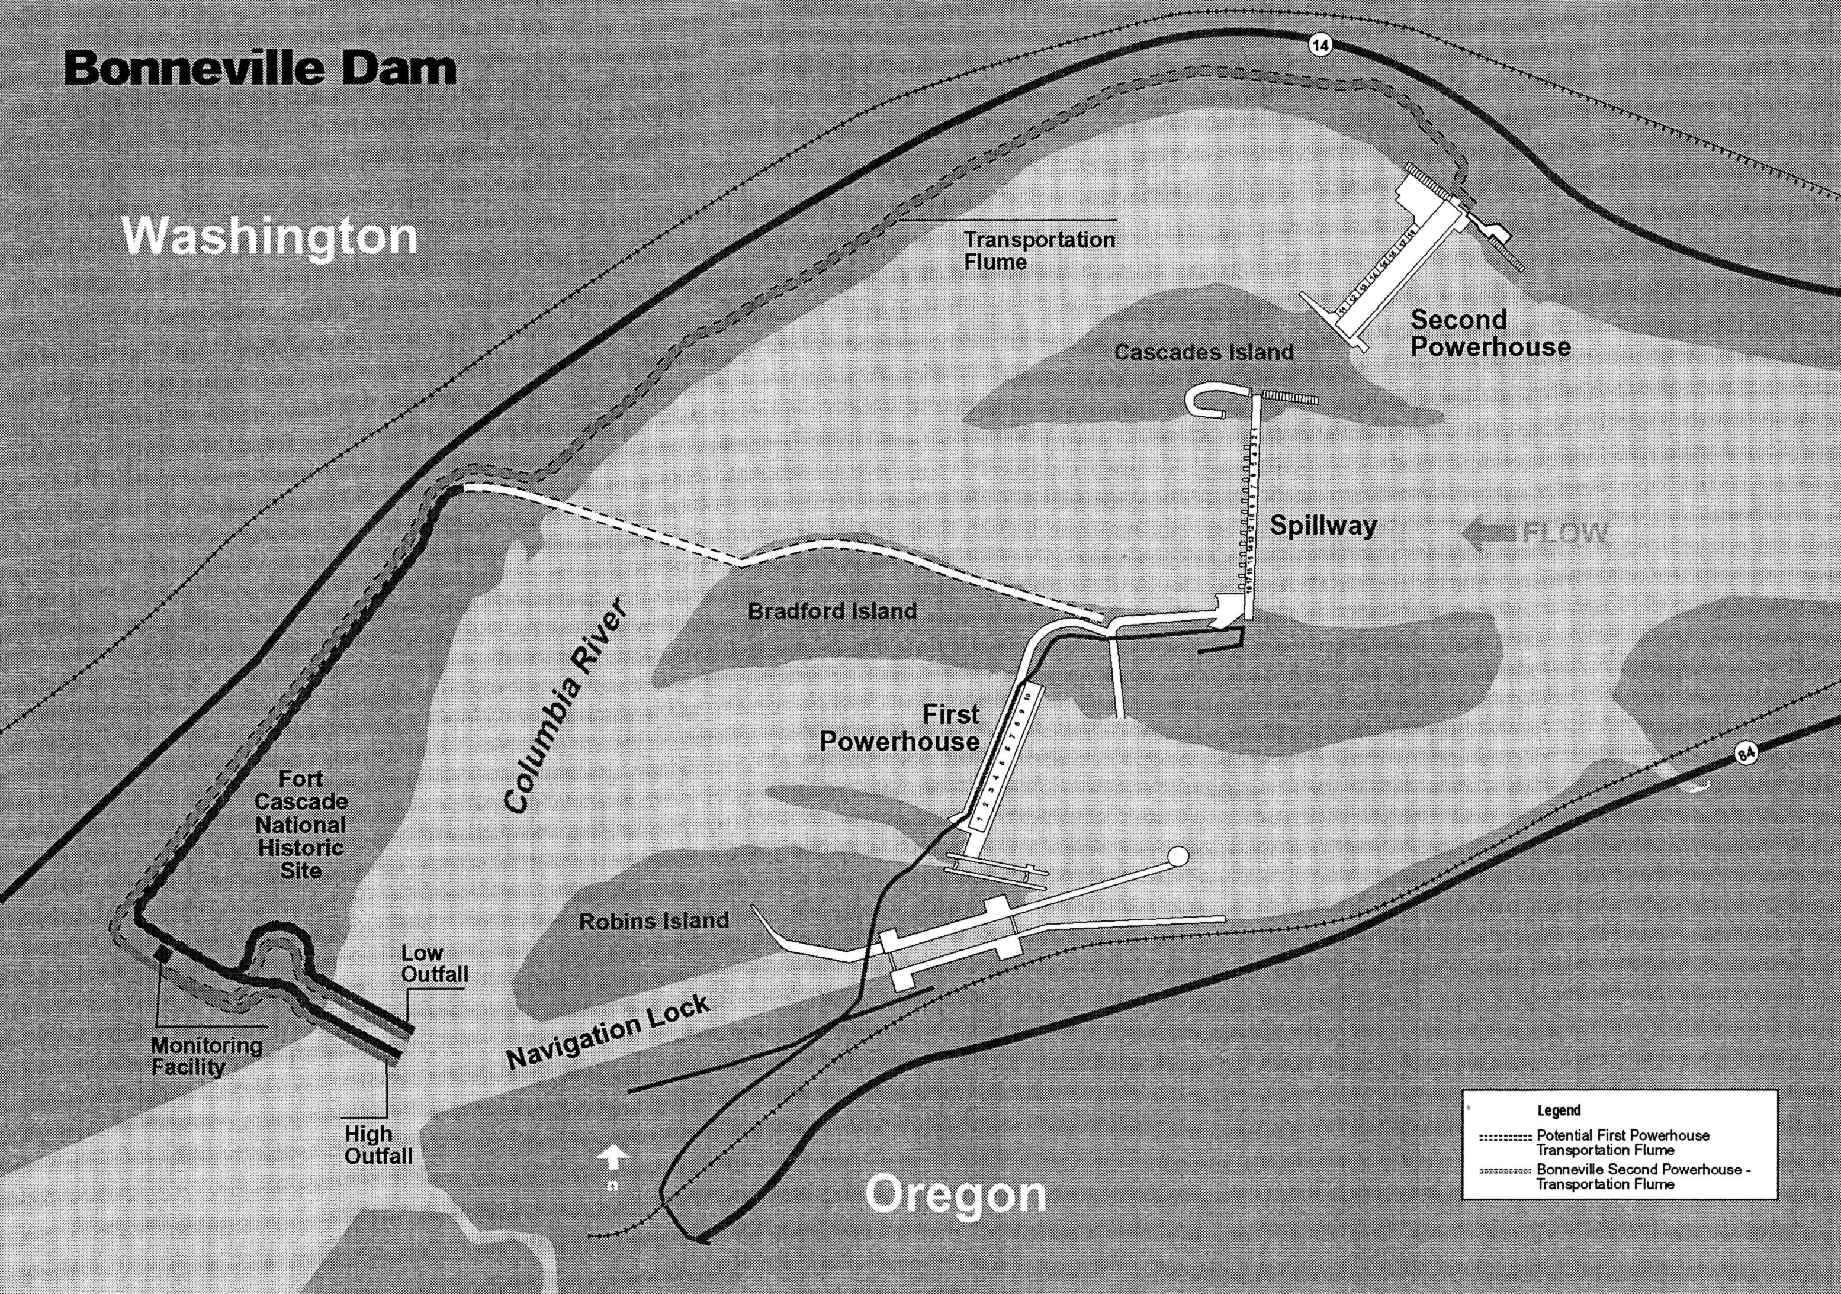
BRZ
Boat Launch
Outer zone
Inner zone

